

Easy, subsidised virtual appointments while we are closed
Kia ora koutou,
If you are unwell over the summer break and need to see a doctor, or if you are out of town for the holidays, we are pleased to let you know that thanks to funding from ProCare, we are able to offer subsidised virtual appointments with a doctor via CareHQ.
Patients with a community services card will pay $19.50 and it’ll cost $49.95 for everyone else for a standard 10-minute appointment with a GP. Please note, this is subsidised down from the standard cost of $79.95, as a benefit of being part of the ProCare PHO Network.
To see an online doctor, all you need is a computer or smart phone. Open your MyIndici patient portal online or smartphone app, click ‘Book Appointment’ and scroll down until you see 'Other Telemedicine Consultation Services, click on CareHQ. Select a GP 10 minute appointment, either CSC or non-CSC and ‘continue’. From here you will be asked to enter some standard details before confirming and making payment.
Please note, you may be required to enter your Community Services Card number for CSC appointments.
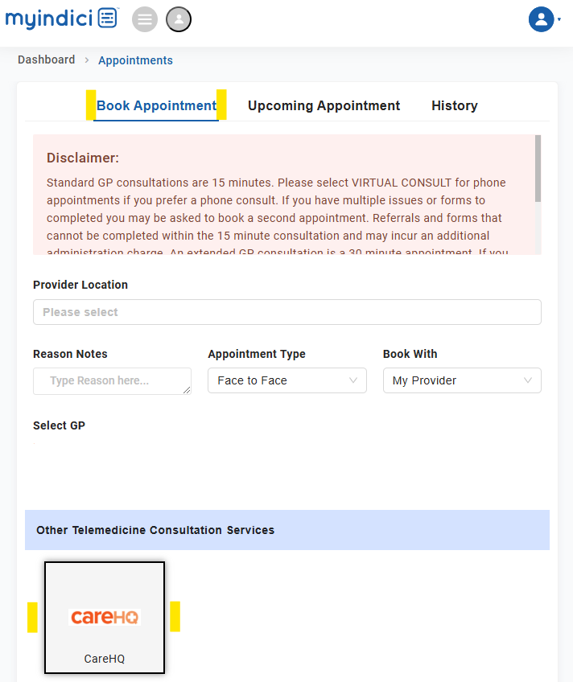
Once your booking is confirmed, you will receive an email confirming the date and time for your appointment. You will then receive a text message and email 15-minutes prior to your appointment with a video link to start the virtual appointment.
Please note - consultations cancelled within 6 hours of the scheduled appointment time will be charged.
If you need a prescription or tests, this can be arranged for you during your online appointment and then sent to the appropriate pharmacy or testing centre.
If you have unreliable wi-fi, not enough data, or do not start your virtual appointment, your GP may call you for a phone consult instead.
Your appointment will be with a doctor from CareHQ, a trusted online service with highly qualified New Zealand doctors, available from 7am – 9pm, 7 days a week (including public holidays).
Please note, virtual consults are suitable for most medical needs, sicknesses or injuries, from common colds, urine infections, migraines and repeat scripts for your pharmacy, through to acne and health counselling. If you are unsure if CareHQ is right for you, please email care@carehq.co.nz and the team will respond as soon as possible. As standard, if you have a medical emergency such as severe pain, collapse, or shortness of breath, please call 111 immediately.
We look forward to helping you at the practice again in the New Year.
Merry Christmas from the team at Mt Eden Village Doctors

